**Architecture diagram**

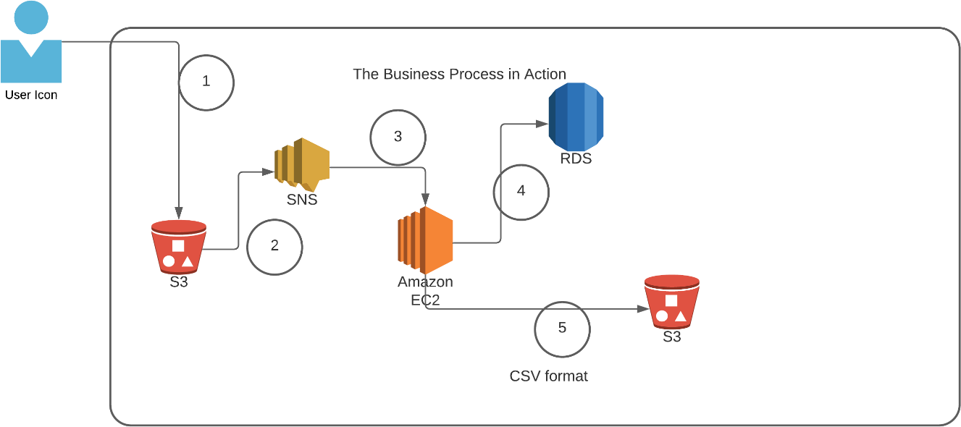

|  |  |
| --- | --- |
| **Architecture Implementation** | |
| 1 | The customer uploads the invoice data to S3 bucket in a text format as per their guidelines and policies. This bucket will have a policy to auto delete any content that is more than 1 day old (24 hours). |
| 2 | An event will trigger in the bucket that will place a message in SNS topic |
| 3 | A custom program running in EC2 will subscribe to the SNS topic and get the message placed by S3 event |
| 4 | The program will use S3 API to read from the bucket, parse the content of the file and create a CSV record and save the details in an RDS database |
| 5 | The program will use S3 API to write CSV record to destination S3 bucket as new S3 object. |

|  |  |
| --- | --- |
| Note | The custom program codebase and sample invoice have been shared along with this workbook on the LMS. |

Step 1: SNS and S3 topic creation

|  |  |
| --- | --- |
| Step number | a |
| Step name | Creation of Source and target buckets |
| Instructions | 1. Navigate to S3 using the Services button at the top of the screen 2. Select "Create Bucket" 3. Enter a source bucket name and use the default options for the rest of the fields 4. Click on "Create Bucket' 5. Repeat the above steps to create a target bucket |
| Expected screenshots | 1. Screen showing created S3 source and target buckets |

<Insert screenshot for a(1) here>

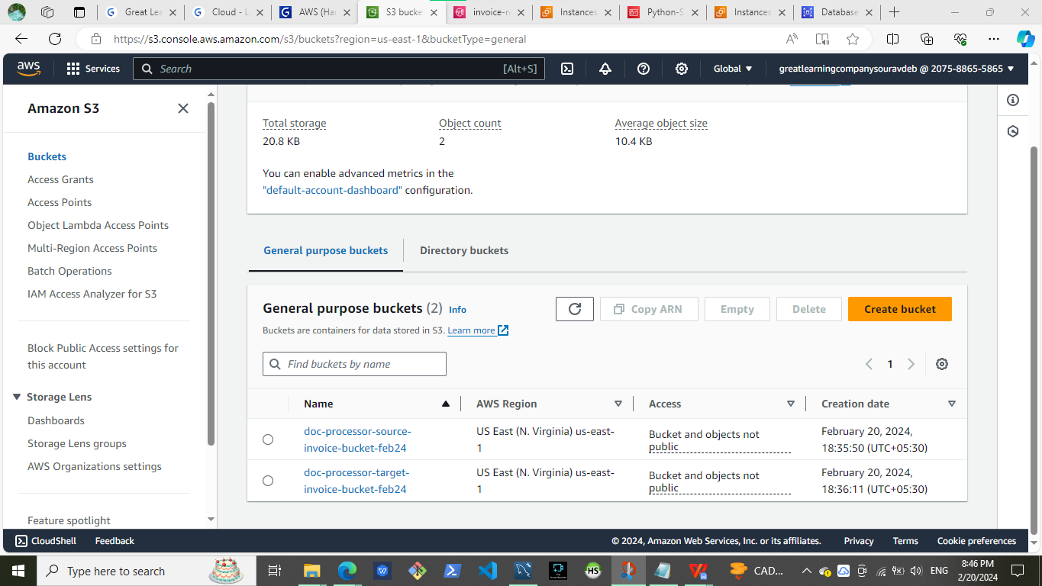

|  |  |
| --- | --- |
| Step number | b |
| Step name | Creation of SNS subscription |
| Instructions | 1. Navigate to SNS -> Topics 2. Click on "Create Topic" 3. Enter the following fields Name : S3toEC2Topic   The other options can be ignored for now   1. Click on Create Topic |
| Expected screenshots | 1. Creation of SNS topic |

<Insert screenshot for b(1) here>

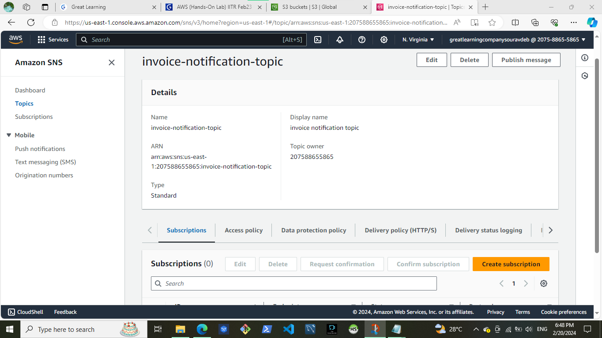

|  |  |
| --- | --- |
| Step number | c |
| Step name | Modification of SNS Access Policy |

|  |  |
| --- | --- |
| Instructions | 1. Navigate to SNS -> Topics and select the topic created in the previous step 2. Note down the ARN shown in the topic details 3. Click on Edit and select "Access Policy". 4. Replace the text in the JSON editor with the following   {  "Version": "2012-10-17",  "Id": "example-ID", "Statement": [  {  "Sid": "example-statement-ID", "Effect": "Allow",  "Principal": {  "AWS":"*"  },  "Action": [ "SNS:Publish"  ],  "Resource": "**SNS-topic-ARN**", "Condition": {  "ArnLike": { "aws:SourceArn": "arn:aws:s3:*:*:**bucket-name**" }, "StringEquals": { "aws:SourceAccount": "**bucket-owner-account-id**" }  }  }  ]  }   1. Replace the bold text with the SNS topic ARN, source bucket name and your AWS account ID respectively. 2. Click on Save Changes |
| Expected screenshots | 1. JSON Editor screen |

<Insert screenshot for c(1) here>

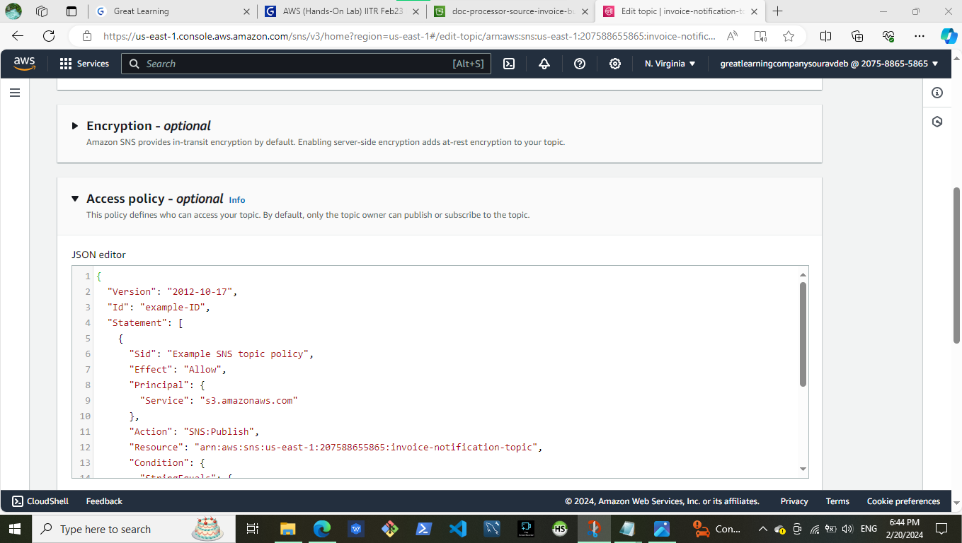

|  |  |
| --- | --- |
| Step number | d |
| Step name | Configuring SNS notifications for S3 |
| Instructions | 1. Navigate to S3 and select the source bucket created in Step 1 (a) 2. Select Properties and scroll down to Event Notifications and select it 3. Select "Create Event Notification" 4. Fillup the details as follows Name : S3PutEvent   Select PUT from the list of radio buttons Destination : Select SNS Topic  SNS : Select S3ToEC2Topic   1. Save Changes |
| Expected screenshots | 1. Event Configuration Screen |

<Insert screenshot for d(1) here>

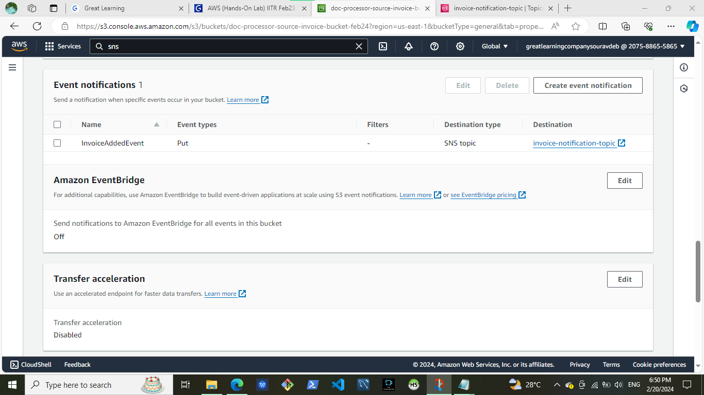

Step 2: Run the custom program in the EC2 instance

|  |  |
| --- | --- |
| Step number | a |
| Step name | Creation of the EC2 instance and RDS instance |
| Instructions | 1. Navigate to EC2 -> Instances 2. Create an EC2 instance with the following parameters   AMI : Amazon Linux 2  VPC : Default  Security group : Ports 22 and 8080 should be opened   1. Navigate to RDS 2. Create an RDS instance with the following parameters:   Engine type : MySql Template : Dev/Test  Set the username and password as required DB Instance class : Burstable  Instance type : t3.micro Public Access : Yes  VPC Security group : Create New ()  Under Additional Configuration, add an initial database name. Take note of this name as it will be required later.  Uncheck “Enable Enhanced Monitoring”  Ensure that the security group created by the RDS deployment has port 3306 open for all incoming connections from all sources. |
| Expected  screenshots | 1. List of instances after creation of EC2 instance 2. List of RDS instances |

<Insert screenshot for a(1) here>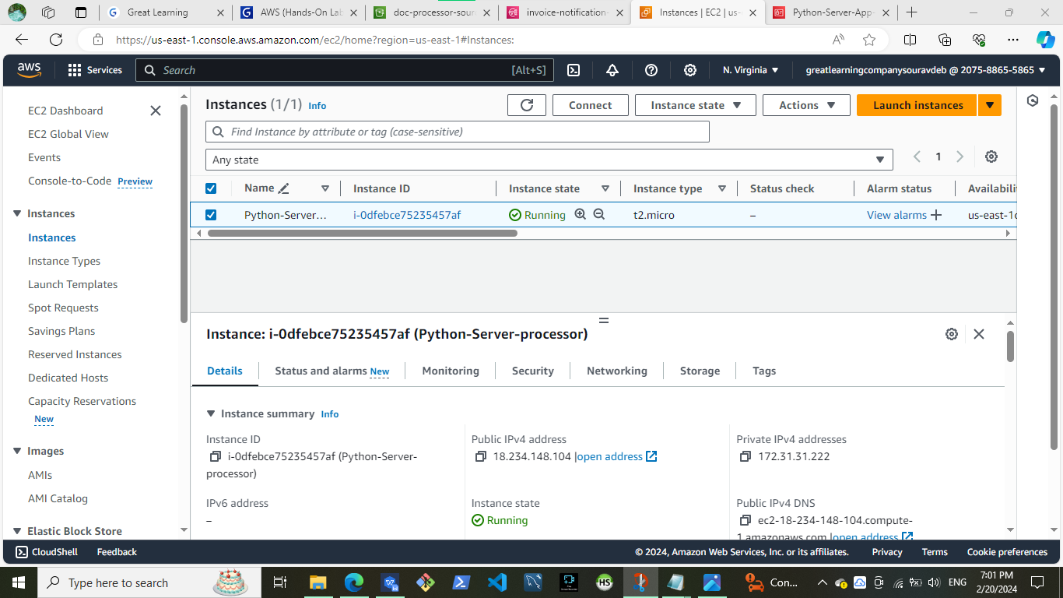

<Insert screenshot for a(2) here>

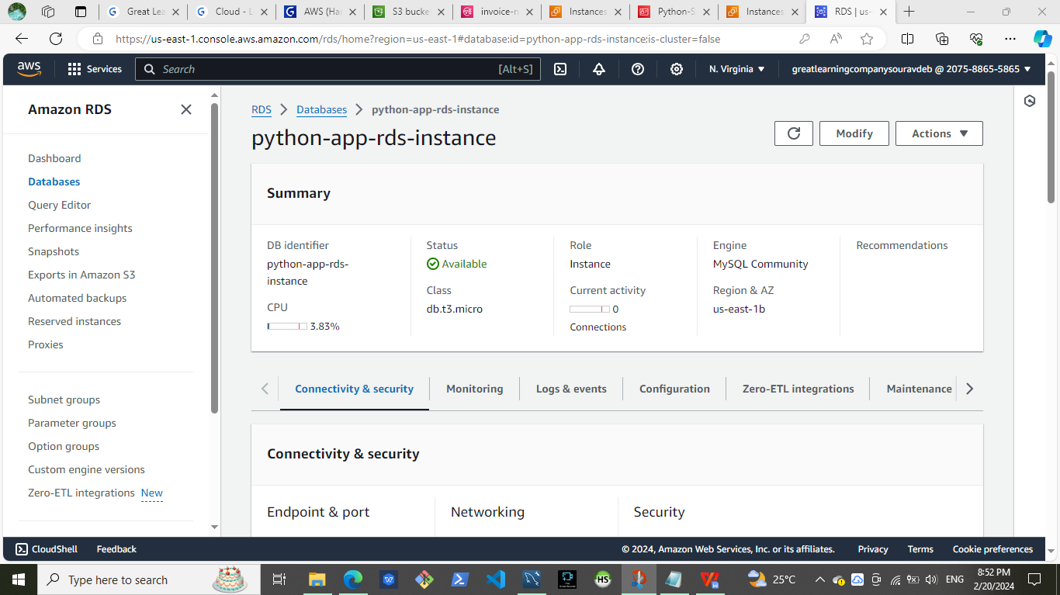

|  |  |
| --- | --- |
| Step number | b |
| Step name | Assignment of IAM role for EC2 instance |
| Instructions | 1. Navigate back to EC2- > Instances 2. Select the EC2 instance created in the previous step and select Actions-> Security -> Modify IAM role 3. Select the role LabInstanceProfile from the   dropdown and click on Save |
| Expected screenshots | 1. Modify IAM role screen |

<Insert screenshot for b(1) here>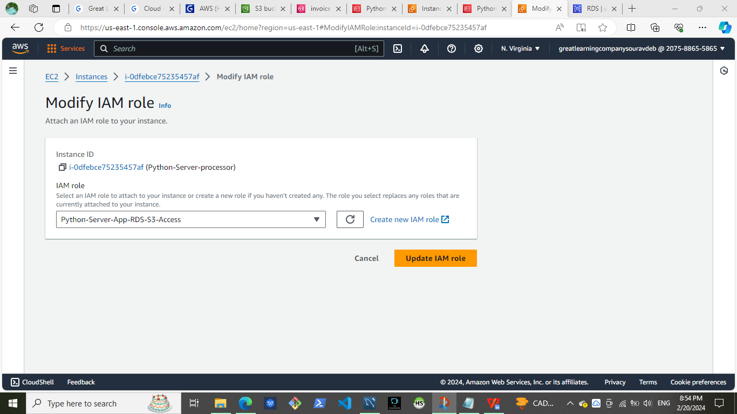

|  |  |  |
| --- | --- | --- |
| Step number | c |  |
| Step name | Configuration and Uploading of custom program |  |
| Instructi ons | 1. Download the file **docproc-new.zip** on your machine 2. Unzip the downloaded file 3. Enter the unzipped folder and open the file [views.py](http://views.py/) in the API folder using a text editor 4. In line number 19-24, modify the target   bucket name to the one created in Step 2  (a) and modify the hostname, username, password and database variables to the values set while creating the RDS database and save the file  5) Copy the folder docproc-new to the home folder of the EC2 instance created in Step 3(a) using scp. Use the command given below  *scp -i <pem> -r ./docproc-new ec2- user@<ip>:/home/ec2-user* |  |
| Expecte d screens  hots | 1) Modifying of the [views.py](http://views.py/) file to point to  the target bucket | 2)Copying the folder to the  EC2 instance |

<Insert screenshot for c(1) here>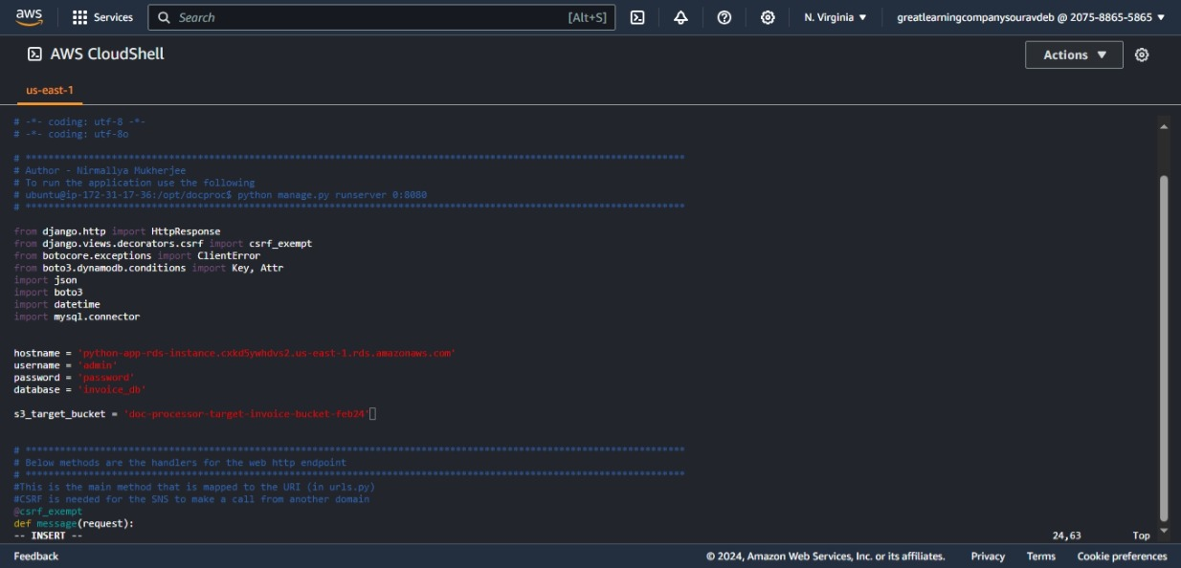

<Insert screenshot for c(2) here>

Step 3: Creation and Verification of SNS subscription and Generation of CSV file

|  |  |
| --- | --- |
| Step number | a |
| Step name | Starting the EC2 custom program |
| Instructions | 1. Log into the EC2 instance using SSH 2. Run the followng commands after successful SSH to start the server sudo cp -r docproc-new /opt   sudo chown ec2-user:ec2-user -R /opt cd /opt/docproc-new  sudo yum update  sudo yum install python-pip -y  python -m pip install --upgrade pip setuptools sudo pip install virtualenv  virtualenv ~/.virtualenvs/djangodev  source ~/.virtualenvs/djangodev/bin/activate pip install django  pip install boto3  pip install mysql-connector-python-rf python manage.py runserver 0:8080  **Keep this terminal window open throughout the rest of the exercise** |
| Expected screenshots | 1. Server in waiting state |

<Insert screenshot for a(1) here>

|  |  |
| --- | --- |
| Step number | b |
| Step name | Creation of  SNS  subscription |
| Instructions | 1. Navigate to SNS in the AWS Console and select the topic S3ToEC2Topic 2. Click on Create Subscription 3. Enter the following details Protocol : HTTP   Endpoint : http://<host>:8080/sns where <host> in the public IP of the EC2 instance Click on Create Subscription   1. In the EC2 terminal window, look for the field "SubscribeURL" and copy the entire link given   **Note: If a message is seen "ValueError: No JSON object could be decoded", it can be safely ignored**   1. Paste that link into a browser window to verify the SNS subscription (Ignore any   messages received in the web browser) |
| Expected screenshots | 1)  Subscription URL in EC2  terminal Window |

<Insert screenshot for b(1) here>

|  |  |
| --- | --- |
| Step number | c |
| Step name | Generation of CSV file |
| Instructions | 1. Download the file **docproc-invoice.txt** provided with this workbook 2. Navigate to S3 in the AWS Console 3. Upload the sample invoice file to the source S3 bucket using the default options 4. Verify that a CSV file is generated in the target S3 bucket. This may take a few minutes 5. (Optional) Login to the RDS instance using your preferred MySQL client and check the table created inside the specified database. |
| Expected screenshots | 1. Generated CSV file in the target S3 bucket |

<Insert screenshot c(1) here>

|  |  |
| --- | --- |
|  | As a product manager, how would you describe the benefits of this architecture to  an client, as compared to an equivalent on-premises architecture? |

**Security :** Your data remains secure and compliant with industry standards. You can implement granular access controls, encryption, and monitoring to protect your sensitive information.

****Flexibility :**** AWS services, you have the flexibility to experiment with different configurations and architectures easily. You can quickly adapt to changing business requirements and iterate on your solution without being locked into a specific hardware infrastructure.

****Durability**** : AWS S3 provides a highly durable storage solution with built-in redundancy and data replication across multiple availability zones. This ensures that your data is safe and accessible even in the event of hardware failures or disasters.

****Automation :**** The use of S3 events and SNS topics enables event-driven architecture, allowing your system to react to changes in real-time.

****Cost-effectiveness**** : You only pay for what you use. Additionally, AWS offers pricing models that allow you to optimize cost.There's no need to invest in expensive hardware or maintain physical servers.